1) Login to GCP management console at:

[**https://console.cloud.google.com**](https://console.cloud.google.com)

2) Use the search box to locate and select your project by searching for the Project ID. In DiscountMate project 2022T3, the project ID is:

**sit-22t3-discountmate-46bf512**

3) Click “Go to the SQL dashboard”.

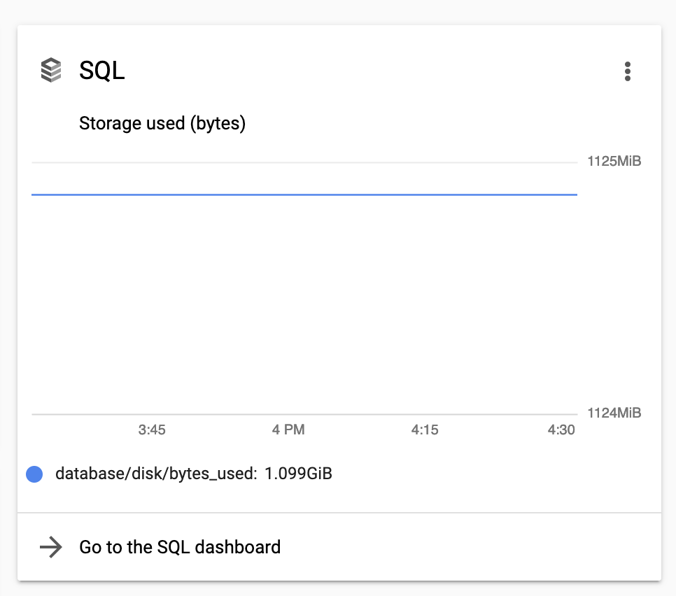

4) Click your created database instance.

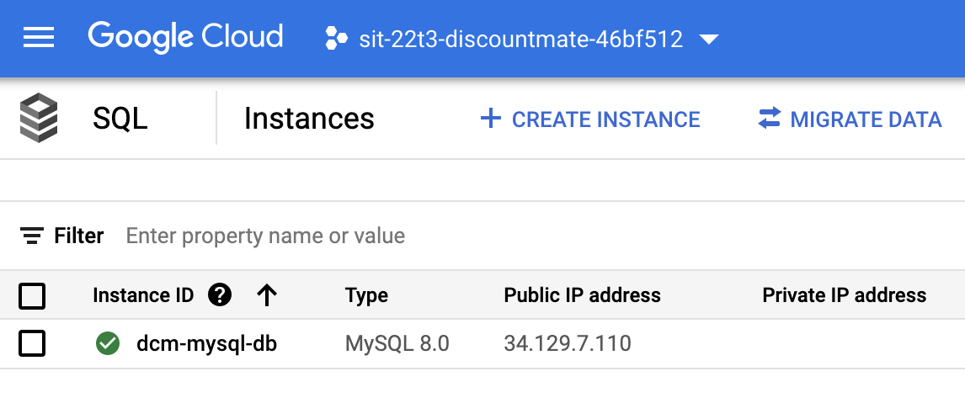

5) Mark down the public IP for your later access use. Click “Connections” from the left panel.

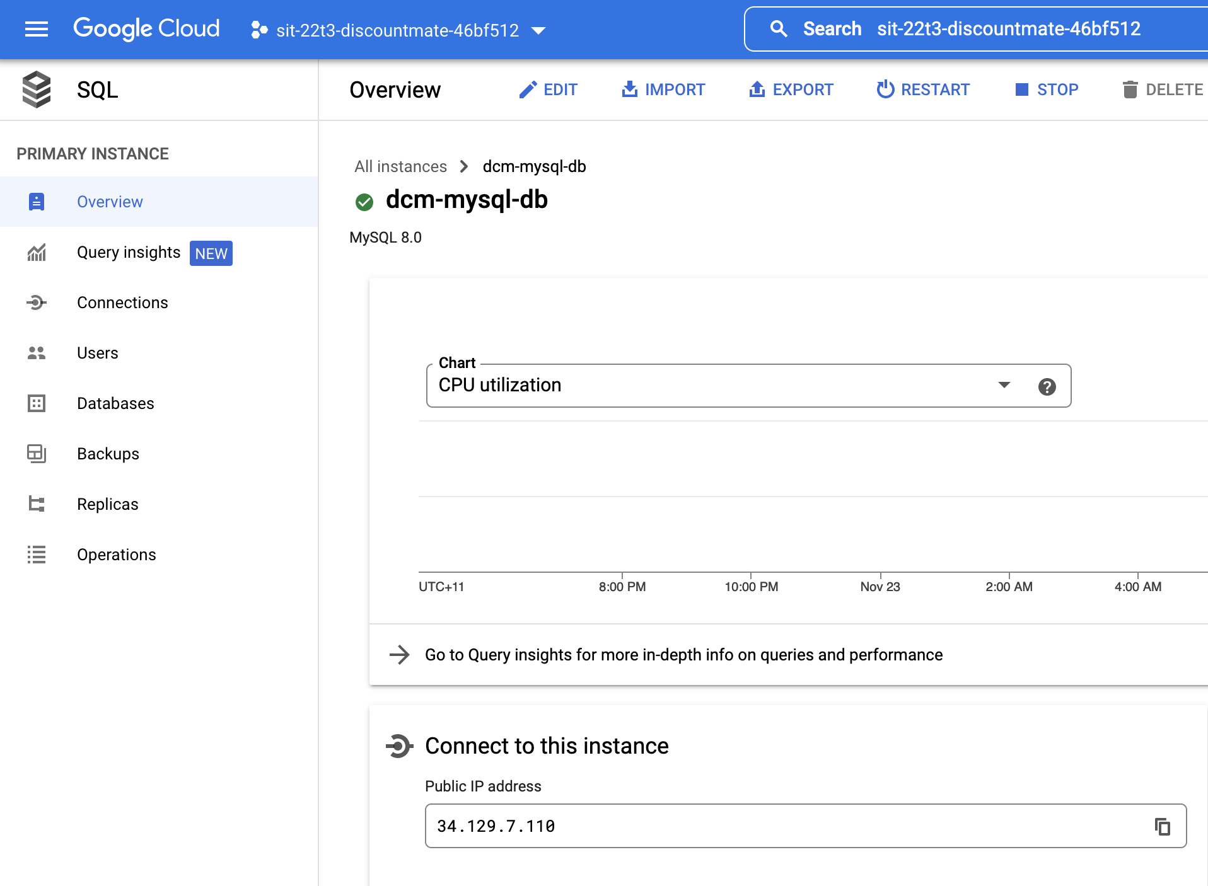

6) Under Authorized networks, click “ADD NETWORK”.

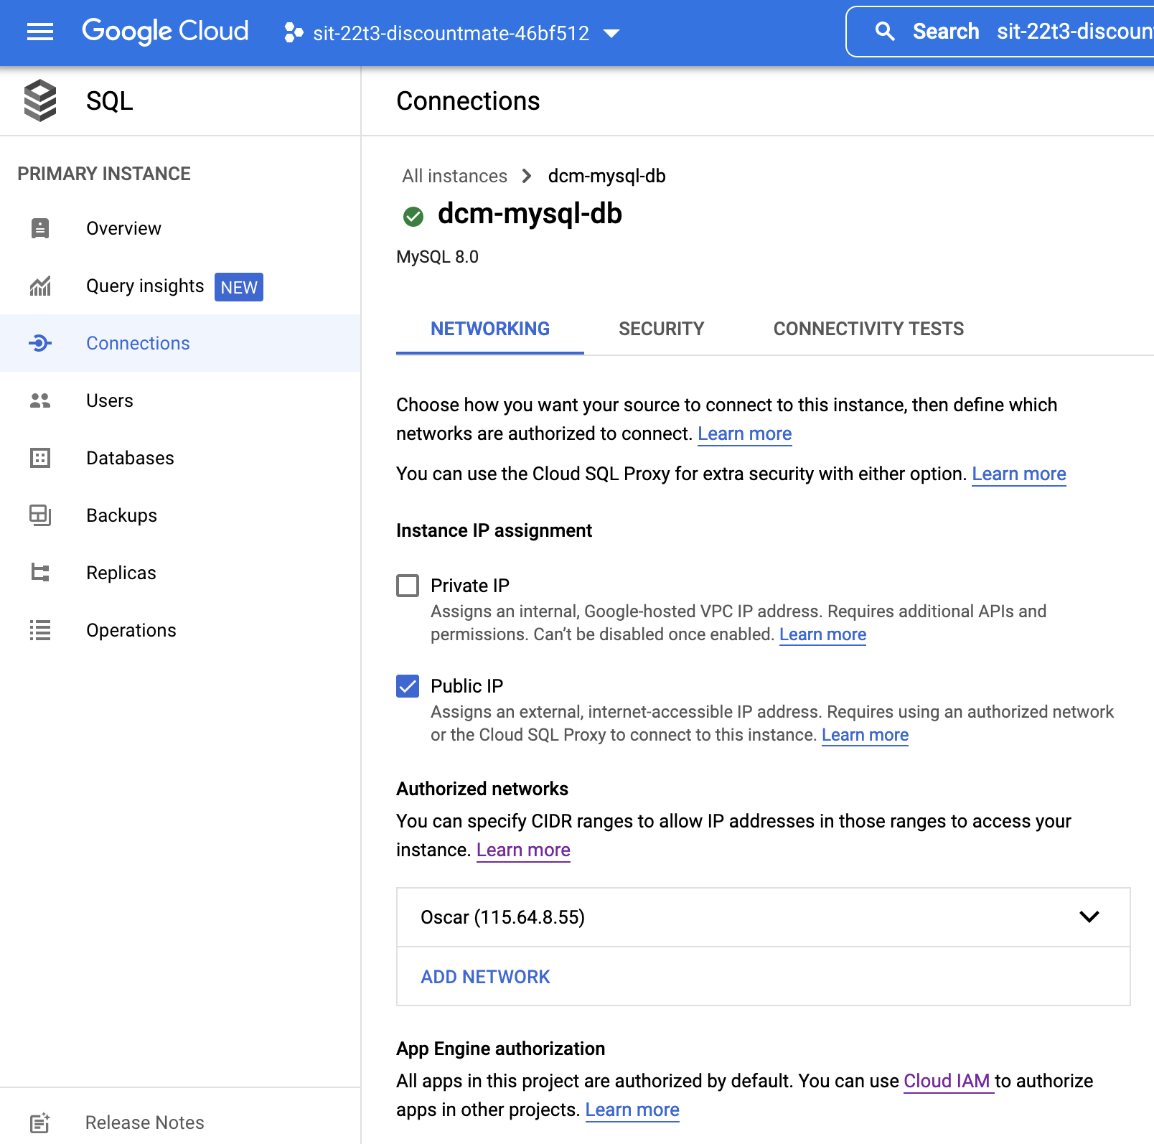

7) Open a new tab in browser, go to: <https://whatismyipaddress.com/>

Mark down the IPv4 of your local computer.

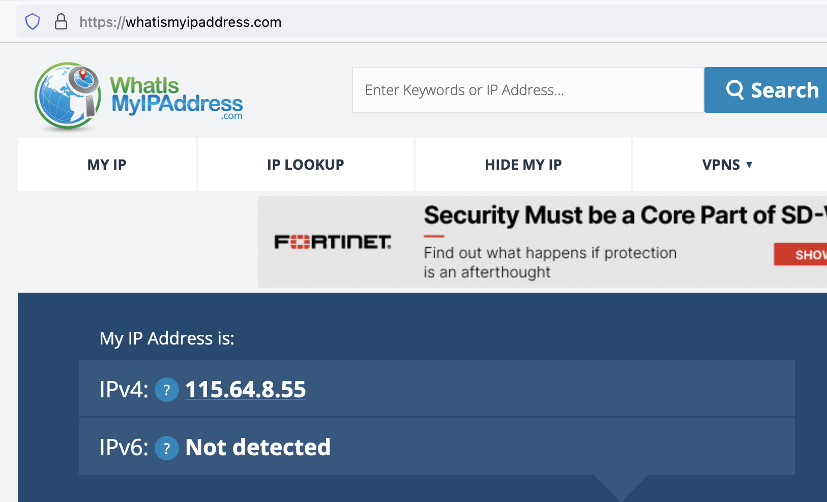

8) Back to the GCP page, in the ADD NETWORK area, fill in your name and the IP you mark down for your local computer to the field “Network”. Click Done, then click Save.

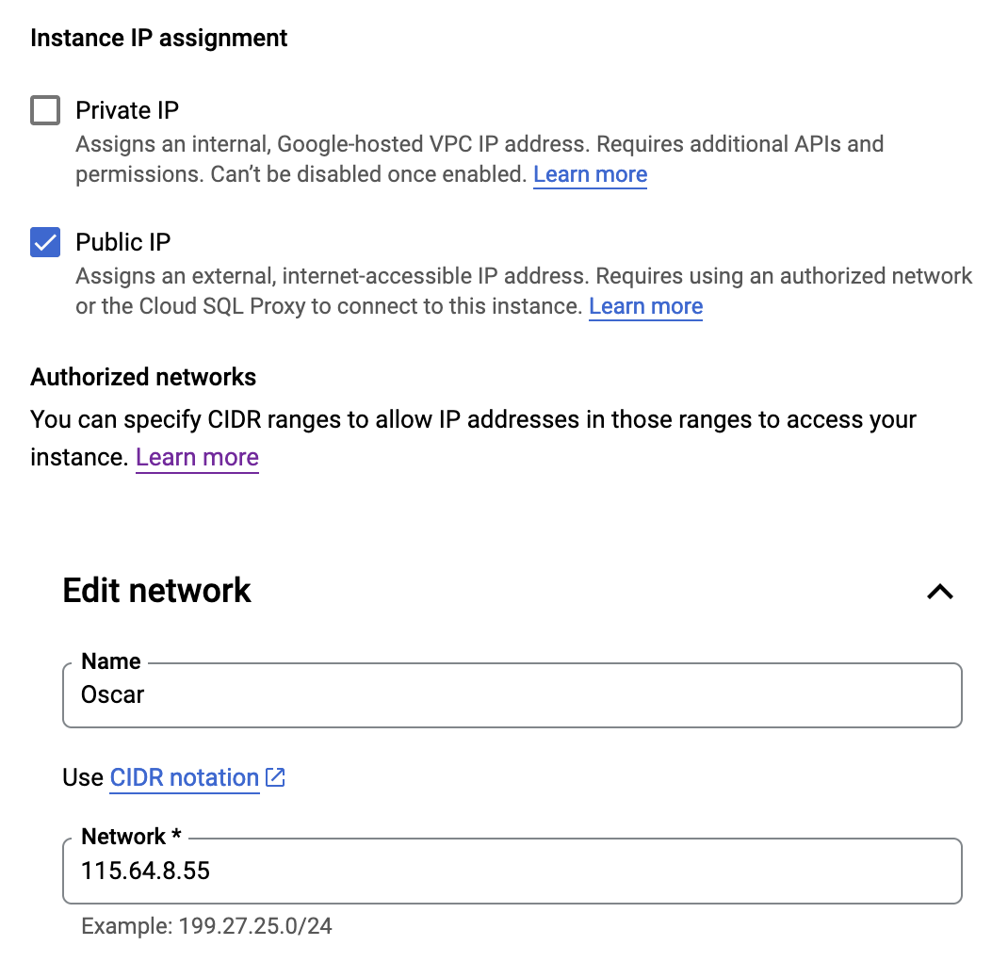

9) Now you have added your local machine IP into the authorized network of this MySQL cloud DB instance. You could now try to access the database from your local computer by follow below steps:

10) Run MySQL Workbench from your local computer. Click “+” to add a new MySQL Connection. On the connection creation screen, input below detail:

Connection Name: (Your own decided name)

Hostname: **34.129.54.95**  (The public ip of the DB instance you mark down from the GCP page)

Username: **[your given login]** (system account created for this project use)

Password: **[your given password]** (system account created for this project use)

11) Click “Test Connection” to make sure the connection is working. When it is working, click Save and then connect to the database.

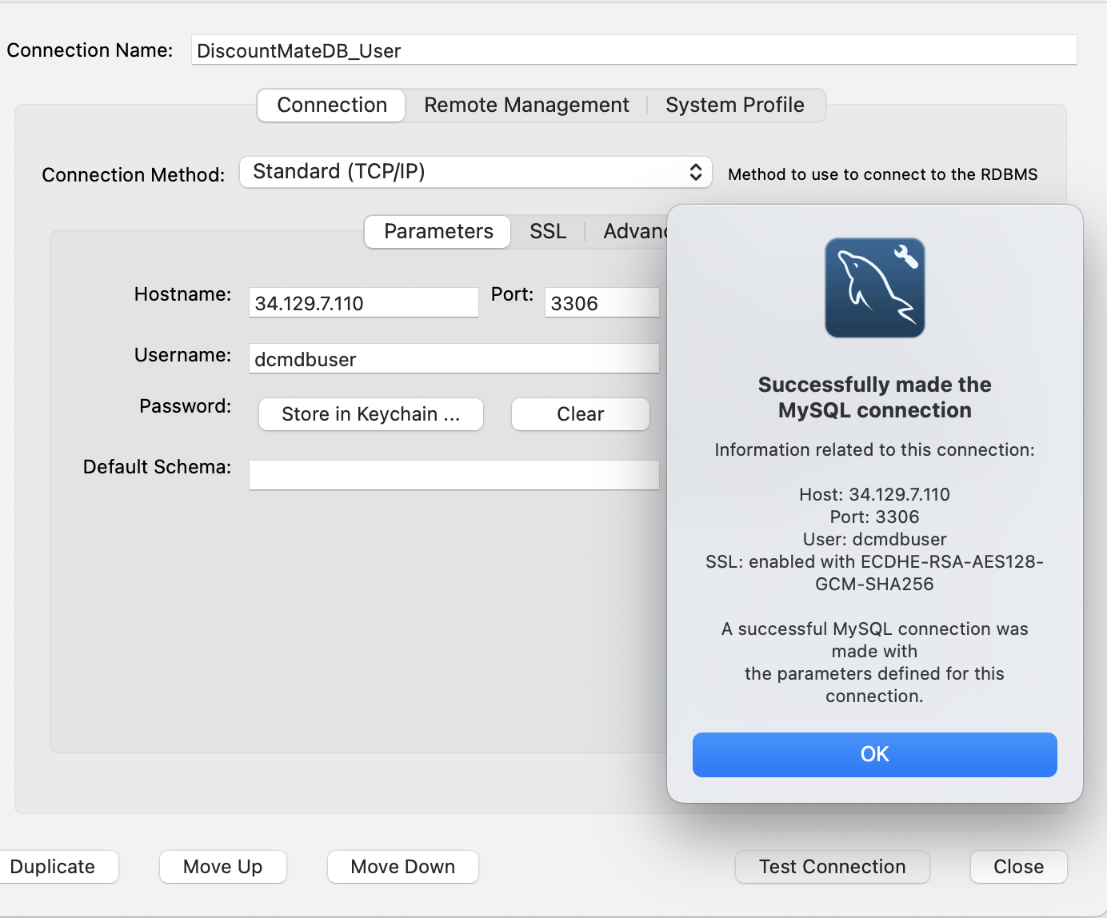

12) In the SQL editor, execute below command to access to the created DB: dcmdb

use dcmdb;

Then now you could execute your own query for your work in this cloud database.

